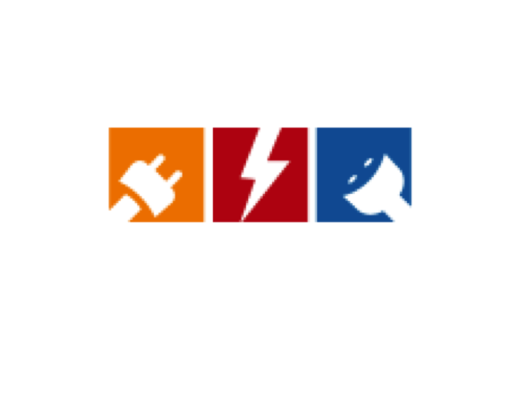

KORILENT a.s.

**EE493 Engineering Design Course**

**“PISTOL DUEL PROJECT”**

**CONCEPTUAL DESIGN REPORT**

|  |  |  |  |
| --- | --- | --- | --- |
| **Project Start Date:** | | 23.10.2015 |  |
| **Project End Date:** | | 15.05.2016 |  |
| **Project Duration:** | | 7 Months |  |
| **Advisor Professor:** | | Afşar SARANLI |  |
| **Yelda GUNGOR** | | 1936947 | e193694@metu.edu.tr |
| **Ilteris Kagan KAHRAMAN** | 1876309 | | e187630@metu.edu.tr |
| **Cengizhan OZMEN** | | 1877349 | e187734@metu.edu.tr |
| **Emre CANBOLAT** | | 1875905 | e187590@metu.edu.tr |
| **Koray CIMEN** | | 1877265 | e187726@metu.edu.tr |

**EXECUTIVE SUMMARY**

KORILENT presents this conceptual design report for the project explained as ‘’A robot taking part in a pistol duel’’.

Korilent A.S. is the company that was currently founded by five dedicated and well educated electrical and electronics engineers. The object of the company is mainly developing new technologies by using the inspiration comes from their passion of innovation.

Customer would like to take part in a duel fight with similar robots. Main objectives are determining opponent, shooting, escaping from bullet, reloading and taking turns. The robot designed by the KORILENT, will have two modes as attack and defense.

In defense mode, solution is to move with a faşt and agile system in a way that opponent cannot detect the position.

In attack mode, solution is to detect and shoot the target in a fast way therefore opponent cannot have time to accelerate.

Hence company has to design a dueling robot that is basically capable of moving around and shooting the opponent autonomously.

Budget of the project will not exceed 100$ since we have exceptional financial analysis skill.

A user’s manual, a warranty certificate, installation and after-sale maintenance service will be provided by the producer.

With skilled team members, KORILENT. guarantees that the company will provide **the most successful and simple solution**.

**TABLE OF CONTENTS**

1. STANDARDS COMPLIANCE4
2. MAIN BODY5
   1. INTRODUCTION5
   2. PROBLEM STATEMENT6
      1. PROJECT GOALS AND OBJECTIVES6
      2. SCOPE OF THE PROJECT7
   3. APPROACH TO SOLUTION7
      1. DESIGN REQUIREMENTS7
      2. ALTERNATIVE SOLUTIONS10
      3. ORGANIZATION PLANS11
      4. TEST PLANS11
   4. SOLUTION14
      1. BODY STRUCTURE14
      2. MOVEMENT SUBSYSTEM15
      3. TARGET DETECTION SUBSYSTEM19
      4. FIRING SUBSYSTEM21
      5. POWER SUBSYSTEM22
      6. TEST RESULTS23
   5. PLANS&PROJECT MANAGEMENT28
      1. TASK DIVISION&RESPONSIBILITIES28
      2. GANTT CHART29
      3. COMPLETED TASKS30
      4. PLANNED TASKS30
      5. POSSIBLE RISKS&CHALLENGES31
      6. DELIVERABLES31
      7. COST ANALYSIS32
   6. CONCLUSION33
3. APPENDICES34
4. **STANDARDS COMPLIANCE**

|  |  |  |
| --- | --- | --- |
| **Standard Item** | **Compliance Status** | **Notes** |
| **Game Field Design(4.1)** | Yes. | Field will be opaque black, flat and borders will be white with at most 2cm width. Sensing capability of the reflectance sensor is less than 2cm. See the test results(4.6) |
| **Turn Taking (4.2)** | Yes. | Target detecting mechanism will take action less than 40 seconds. Even if a problem occurs in shooting, an internal time out which is less than 40 seconds will be implemented on robot to ensure that it makes use of its turn before 40 seconds time out. Besides, bluetooth or radio module shall be used to send a simple signal to robot for its turn taking. |
| **Bullet/Projectile(4.3)** | Yes. | We are planning to use standard table tennis ball with specified orange colored. |
| **Safety (4.4)** | Yes. | We shall do tests regarding the strength of the shots with the specified material. We have a sample of the material.Tests will be done from 1 meters. |
| **Communication with the outside devices(4.5)** | Yes | We shall use the computer only to send position data(measurement) of the opponent which is figured out from image processing. Besides, a simple signal will be sent to robot to inform its turn taking condition. Related work is explained in section 4.4.3 |
| **Bullet/Projectile Reload (4.6)** | Yes. | Reload mechanism shall be away from the opponent side so that going out of the field excluding the opponent side will be achieved. |
| **Opponent Recognition(4.7)** | Yes. | At least %50 of the visible area of the robot will be covered with the specified colored paper so that it will not have sound or light absorbing feature. Responsible person Eylem Tokat provided the sample object with specified color. |
| **Audiences(4.8)** | Yes. | A warning sign will be provided during the competition for audiences not to get closer than 50cm to the field. |
| **Stray Bullets/Projectiles (4.9)** | Yes. | Field shall not contain a boundary higher than the ground level so that no bullet will stay in our side of the field. However, if a bullet does not leave the field, then we shall request from the refree to remove the bullet. |

Table 1-Standard Compliance

1. **MAIN BODY**
   1. **INTRODUCTION**

In this project, the main objective is to design an autonomous robot which takes place in a pistol duel with an opponent robot. This duel event occurs on a 2mx1m field, and the design should be able to shoot towards the opponent from a certain distance and score by hitting it. Moreover, the design should be able to evade from bullets of opponent robot. Namely, the main features are:

* To detect an opponent which is moving
* To detect the boundaries of the duel field
* To move rapidly to evade the bullets
* To do these tasks autonomously

A detailed approach as a solution to this project is presented in the following sections of this report. One can also find the clear definition of the problem.

Mainly, we need to construct some sub-systems to handle the overall system. The sub-systems that we see them as the most essential are movement sub-system, detection sub-system and firing sub-system. These sub-systems will be combined in a mechanical manner, and will work together as a whole.

There could be many different solution ideas to the problems that the project consists, but as Korilent we think that the solution should be the simplest and the most cost-effective one among the other solution ideas. In the following sections, there is particular information about each sub-system and solution idea.

* 1. **PROBLEM STATEMENT**
     1. **PROJECT GOALS AND OBJECTIVES**

The aim of the project is to design a robot that is going to do a “pistol duel” with a similar kind of an opponent robot, in an interactive way. Admitting that this is the main goal of this project; there are several conclusions that can be reached as the objectives of the project, which are listed below:

* **High Mobility**

This can be considered as an essential objective. In both turns of the duel (i.e. attack mode and defense mode), the robot must speed up and slow down very fastly. With a high rate of acceleration, it will be harder for the opponent to detect and shoot our robot and easier to dodge a bullet, and also will be easier to catch and attack the opponent.

* **Minimal Size and Neatness**

Making the outer design compact and neat is an important objective for us. This is important in case of dodging easier, but can be considered as more important in the way of robot’s being long-lifed.

* **Fast Reaction Time**

We desire to minimize the reaction time of the robot when it hits a boundary and the detection of the opponent in the attack mode. For boundary detection problem, it is important that our sensor sends the information very fast, our MCU processes the information fast and our motors should instantly react. This effects our material decision and also our algorithm approach. For detection of the opponent and shooting, same rules apply; as in sensor’s sending information, processing this information by MCU and shooting by the actuator. This might be considered as the most important objective of the project.

* **Material Quality**

We consider this project as a long-term project, therefore it is important for us to design a robot that will be used for maximum time possible. For this purpose, the quality of the materials chosen is as important as the design for us. Therefore, this is an important objective for us.

* **Cost-Effeciency**

We cannot ignore the economy factor. There’s a predefined upper bound of the project payment. While the cost of the robot must be as lower as possible than the predefined value, it should work as much efficient as possible.

* + 1. **SCOPE OF THE PROJECT**

In order to achieve a satisfactory result, based on the objectives defined above and the project definition; followings are determined as the scope of the project:

* Maximum dimensions of the robot should be less than 20x20cm.
* The robot should be able to detect the opponent from 1.5 meter.
* 2 geared DC motors must be used in order to provide the sufficient torque to reach the high acceleration as desired.
* The diameter of the wheels should be higher 5 cm in order to move fast in the field as desired.
* The whole system must cost lower than 150 USD.
* The final system must be ready by the end of May, 2016.
  1. **APPROACH TO SOLUTION**

The motivation behind the project is to construct an autonomous robot, which will operate in a ‘’Pistol Duel’’ against similar robots. The main objectives are detecting the opponent, aiming and shooting in such a way that the bullet’s first contact will be the opponent. Since the opponent is a similar robot, their main objectives are the same. This shapes another feature, which is the robot that the designed robot must move fast and agile as much as possible to prevent getting shot. To accomplish the overall project, the objectives must be reduced into requirements and various approaches must be taken into account to obtain the smartest decision.

Along the way of the project, requirements, alternative solutions and test plans were taken seriously and will be mentioned in the report.

* + 1. **DESIGN REQUIREMENTS**

Design requirements state the important characteristics that the design must meet

in both engineering sense and customer sense.

|  |  |
| --- | --- |
| **ID\*** | **REQUIREMENTS** |
| CR1 | Constructed robot must be autonomous. |
| CR2 | Contestant must design a 1mx1m platform, which is the boundary for robot to stay inside. |
| CR3 | Robot must be able to take the turn by itself. |
| CR4 | Direct hits will be count as score, not bounced hits. |
| CR5 | Bullet weight and size should not exceed those of a table tennis ball. |
| CR6 | In case of a need, robot must reload autonomously. |
| CR7 | No hardwiring is allowed to cross the boundaries. |

Table 2-Customer Requirements

(*CR stands for Customer Requirement.)

|  |  |
| --- | --- |
| **ID\*\*** | **REQUIREMENTS** |
| SR1 | Fast and agile system must be constructed prevent from getting shot. |
| SR2 | Sharp opponent detection system is necessary. |
| SR3 | Electrical Power Subsystem must be able to provide power to devices whenever needed. |
| SR4 | Reload and firing mechanism must be small and light. |
| SR5 | Fast and wide scanning of space to determine opponent. |
| SR6 | Proper distance sensor to estimate the opponent movement and position. |

Table 3-System Requirements Defined by Engineers

In addition to these requirements, the decisions made in Standard Committee are specified in the Standard Report. A general overview;

* Game Field Design: Color of the platform must be opaque black. Color of the boundary must be white. Width of the boundary must be the same as width of the standard electrical tape (19-20 mm). Height of the platform can be 1.5 cm maximum from the ground. Each team can use any material to construct their own game field including the outside of their own half field.
* Turn Taking: There will be a time out specified as 40 seconds to take to turn and fire to opponent. Also sending a simple signal to robot in order to notify it to take the turn is allowed.
* Bullet Specification: Color must be standard tennis ball orange. The maximum volume must be 4cm3.

**SR stands for System Requirements

* Opponent Recognition: At least 50% of the visible area from viewpoint must be green as specified reference number. Also material cannot be sound or light absorbing.
  + 1. **ALTERNATIVE SOLUTIONS**

These solutions for the project are discussed to find a solution that looks different or performs better, is more cost effective, or to overcome a specific site problem.

Also alternative solutions are necessary for designers to come up with a proposal that provides the best outcome for the project. So far, Korilent has discussed the alternative solutions for robot to remain inside the borders, detecting the target and firing mechanism.

**Staying within the Borders**: This is an important requirement and specified in Standard Committee as color and size. Restrictions are to have a black platform and white borders along the sides. Even though the line must be white, as specified in the committee, it is also specified that each team can use and construct their own half field at outside. This gives a chance to use different color outside the every white side. Advantage is to determine the robots position with respect to given side color. For instance, if red is the right side, robot will be able to turn against the opponent side. Two solutions were discussed for this purpose and given in Table 4.

|  |  |
| --- | --- |
| **White Color** | **Various Color** |
| * Low Cost * Easy to Implement * To decide the way extra implementation is needed | * High Cost * Harder to Implement * Advantage of deciding the way of turn |

Table 4-Alternative Solutions for Staying within Borders

**Detecting Target:** Main consideration of the movement subsystem is the accuracy of the target. Detecting the target can be done in various ways, three of which are utilization of ultrasonic sensor, IR sensor or image processing technique. Surely, each of these methods comes with their according advantages and disadvantages.

|  |  |  |
| --- | --- | --- |
| **UltraSonic Sensor** | **IR Sensor** | **Image Processing** |
| * Low Cost * Easy to Implement * Broad Angle of Sight * Long Distance Measurements * Slow Operating Speed | * High Cost * Easy to Implement * Narrow and Accurate Measurements * Short Distance * Relatively High Operating Speed | * High Cost * Hard to Implement * Very Accurate * Fast Operating Speed * Needs Complex Algorithms * Needs noise immunity |

Table 5-Alternative Solutions to Detecting Target

**Firing Mechanism:** To get the best shot at the opponent, two different ways are compared in Table 6.

|  |  |
| --- | --- |
| **Use of Spring** | **Use of Wheel** |
| * Low Cost * Easy to Implement * Fast * Very Accurate * High Power Consumption | * Higher Cost * Hard to Implement * Slower * No waiting time as pushing spring |

Table 6-Alternative Solutions for Firing

* + 1. **ORGANIZATION PLANS**

Early discussion in the design process will clarify problems and solutions. Therefore designer will know what information and evidence that the project needs to progress. Our discussions and important decisions made so far are highly on Micro Controller Unit, body of the robot, sensor for borders and the motors. Also solutions for detecting the opponent, firing mechanism and remaining inside borders are selected and will be mentioned in the report.

* + 1. **TEST PLANS**

Four important tests were completed in the last month. Three of them aim to determine the opponent. The last one is about the staying inside the borders.

***Sonar Test:*** Goal of the test was to determine the distance between the opponent and the constructed robot. The selected sensor was HC-SR04.

|  |  |  |
| --- | --- | --- |
| **Procedure & Number** | **Objective** | **Expectance** |
| 1-Sensor is moved perpendicular to wall from 500 cm. | Determination of the real life range | 2cm-400cm range |
| 2- From 100 cm, sensor angle is changed slowly to see the measurements. | Determination of real life measuring angle | 15o range |
| 3-Sensor mounted on servo motor (Turnigy) and algorithm used to follow target. | Examine the behavior of sensor under opponent movement. | High speed measurement |

Table 7-Procedure for Sonar Test

***IR Test:*** Test is done to compare the results of sonar test with this one and see which one is better to use for opponent detection. The used sensor is Sharp GPY0A21 IR.

|  |  |  |
| --- | --- | --- |
| **Procedure & Number** | **Objective** | **Expectance** |
| 1-Sensor is moved perpendicular to wall from 100 cm. | Determination of the real life range | 10cm-80cm |
| 2- From 100 cm, sensor angle is changed slowly to see the measurements. | Determination of real life measuring angle | 4o |
| 3-Sensor mounted on servo motor (Turnigy) and algorithm used to follow target. | Examine the behavior of sensor under opponent movement. | High speed measurement |

Table 8-Procedure for IR Test

***Movement Subsystem Test:*** The goal is to ensure that vehicle does not go out of the borders of its own field.

|  |  |  |
| --- | --- | --- |
| **Procedure & Number** | **Objective** | **Expectance** |
| 1-Sensor is placed at 1cm above the ground | Determination of the optimum measuring distance | Distinguishing the black and white colors successfully |
| 2- Sensor is integrated with microcontroller and drivers | Successfull communication between MCU, sensor and motors | Change in behaviour of the motors when the white line is detected |

Table 9-Procedure for Movement Test

***Image Proccessing Test:***

|  |  |  |
| --- | --- | --- |
| **Procedure & Number** | **Objective** | **Expectance** |
| 1-Test of laptop webcam | Determination of the optimum measuring distance and angle of sight | Range of 2 meters and width of 1 meter |
| 2- Algorithm capability is tested | Observation of the accuracy of the color detection algorithm | Noise free detection and tracking of specified colored object |

Table 10-Procedure for Image Processing

* 1. **SOLUTION**

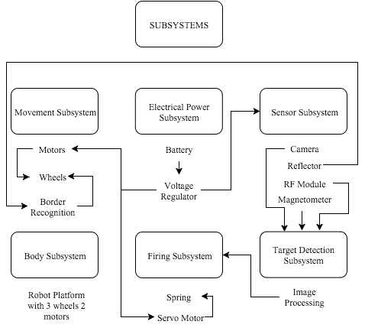

Figure 1-Overall Subsystem Block Diagram

* + 1. **Body Structure**

We designed our undercarriage to allocate sufficient amount of space to each component. As one can easily see from below figure, boundary detection (reflector) part is placed under the carriage at the front side of it. So, our design is able to notice the boundaries without touching out of the boundaries.

In our undercarriage design, there are two appropriate places for two wheels, which are driven by DC motors, and there is a castering wheel at the behind of the undercarriage.

There is also enough space to place other components such as microcontroller, firing system etc.

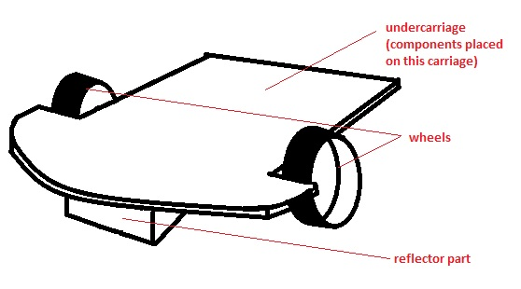

Figure 2-Chasis

* + 1. **Movement Subsystem**

Moving and maneuvering in the game field is essential. Movement subsystem involves the movement of the whole robot in forward and backwards directions, returning and also braking. Main requirements for the movement subsystem are moving in any direction and staying within the borders. Movement and orientation in robotics involves selecting proper motors, wheels and the main body.

General block diagram for the movement system is shown below.

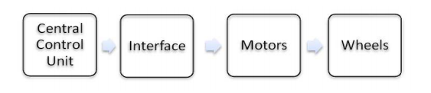

Figure 3-Overall Movement Subsystem

Control signals to the vehicle come from central processing unit. However, current level of the control signals from the controller side is not suitable to drive a motor although the voltage level is sufficient. Output voltage level of a microcontroller can be up to 5V, which can meet the requirement of the motor. However maximum output current that any I/O pin of the microcontroller can supply is approximately 25 mA but motors may sink up to 1A input current. Hence, there is a need for a interface between the microcontroller and the motors. A common way to control the speed of the motor is PWM technique. Microcontroller is able to provide PWM output signal. Interface is able to compare the average value of the PWM signal with a reference voltage level and supply needed current to drive the motors with desired speed.

***Interface:***

|  |  |
| --- | --- |
| **Driving IC** | **Driving Circuitry** |
| * Low cost * Low consumption * Small Size * Overcurrent, thermal , short circuit protection and high noise immunity | * High Cost * Hard to Implement * Large Space Occupation |

Table 11-

***Motors:***

|  |  |  |
| --- | --- | --- |
| **Servo Motors** | **DC Motors** | **Step Motor** |
| * High Cost * Low consumption * High Speed * High Torque * Easy to control * Not suitable for continuous movement | * Low cost * Low consumption * High Speed * High Torque * Needs Gear * Adjustable Speed * Suitable for continous movement | * High Cost * Low consumption * Low speed * Low torque * Complex implementation |

Table 12

***Wheels:***

|  |  |
| --- | --- |
| **Standard Wheels** | **Omni Wheels** |
| * Low cost * Two-way movement * Easy Control | * High Cost * Omni direction capability * Complex control |

Table 13

***Vehicle Driving Mechanism:***

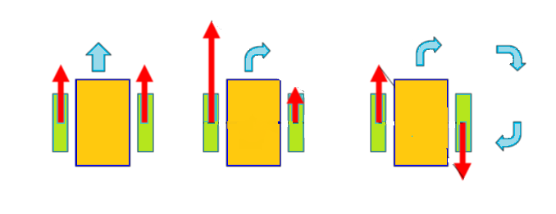

Figure 4-Driving Mechanism, Green color for wheels.

Vehicle shall contain two standard wheels that actually drives the vehicle and a castering wheel to provide stability on a flat platform. Two standard wheels are driven by two DC motors seperately. According to the power given to the motors, vehicle will be able to turn in any direction.

|  |  |  |
| --- | --- | --- |
| **States of Movement** | | |
| **Left Motor** | **Right Motor** | **Direction** |
| 0 | 0 | Stop |
| 1 | 1 | Forward |
| 1 | 0 | Right |
| 0 | 1 | Left |

Table 14

***Border Recognition :***

One of the responsibles of the movement subsystem is to keep the vehicle within the borders. There are various ways to achieve this task. However, reflectance sensor is a cheap, effective and easy to implement. According to the standards, field shall be black and the borders will be remarked with white lines with a 2cm width at most.

***Solution:***

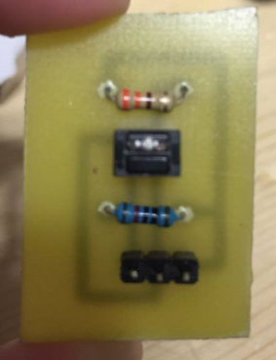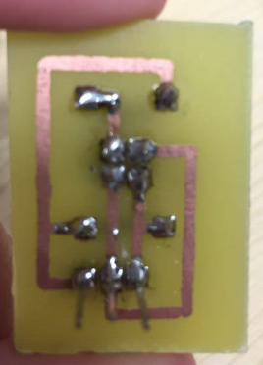

Figure 5- Manufactured PCB for Reflectance Sensor

As Korilent, we manufactured a PCB consisting of reflective object sensor circuitry. IR reflective object sensor is an analog output type sensor. According to the light reflectance ability of the surface, conductivity of the phototransistor changes. Change in conductivity can be evaluated with a change in the voltage at the collector terminal. According circuit schematic is given below.

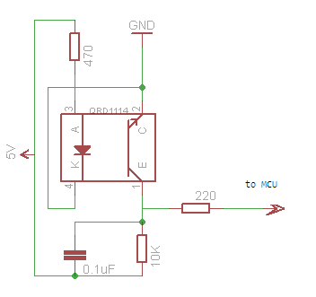

Figure 6-PCB Circuitry

As stated before, output is analog type. With a certain thresold voltage value, reflectance capibility and thus the color of the surface can be figured out. If the voltage level at the output is lower than the thresold value, surface is assumed to be white which is the border lines. Otherwise, it is assumed to be black which is the inside of the field. According to the surface that is detected, decision will be made by MCU.

Flow diagram of the the related algorithm is provided in Figure 7.

Forward Motoring(Both)

Turn Over

Output is lower than thresold?

Figure 7-Flow Diagram of Movement System

* + 1. **TARGET DETECTION SUBSYSTEM**

Target detection system involves detecting the target based on its color which is determined as green by the standard committee. Therefore, aim of the robot is to detect the green color and lock into it. The whole process should be in real time with a specific sufficient frequency. This is achieved by video streaming. Involved components are as follows:

* A camera
* Computer (possibly laptop due to its mobility)
* Software (possibly MATLAB due to its capabilities)
* Serial Port Cable(USB)

Block diagram of the subsystem is shown in Figure 8.

RECEIVER

TRANSMITTER

COMPUTER(MATLAB)

CAMERA

MICROCONTROLLER UNIT

ACTUATOR

Figure 8-Block Diagram of Detection

Main consideration is to track the green colored object. Since any hardwiring is allowed outside the game filed, we shall place a camera outside the field pointing at the field of opponent constantly. Taken image data will be streamed from serial port into laptop. MATLAB will detect the position of opponent and send relative data to the robot with a proper telecommunication system which will be possibly bluetooth or a RF radio. Recieved position data on the vehicle will be used to send proper signal to the actuators which will consist of firing system mounted on a motor that is capable of rotating for full cycle.

Image processing involves complex algorithms. Color detection can be achieved by the help of RGB values that is embedded in the image array. However, in practice, environment may be very noisy. Light intensity, shadows or green colored object presenting outside the field may disturb the detection system. Therefore, using RGB components may not be efficient. Instead, HSV colormap can be used to detect a specific color with minimized noise.

* RGB components: Red,Green and Blue components of environment are stored in an array
* HSV colormap: Hue, Saturation and Value components of environment are stored in array

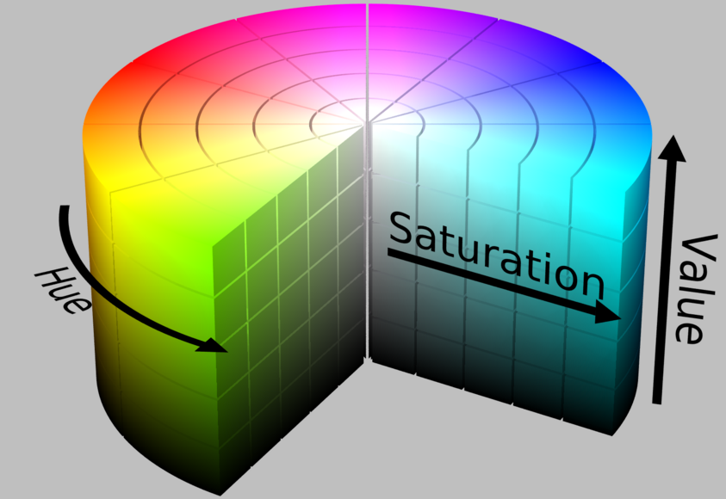

Figure 9-Dimensions of HSV Colormap

The advantage of HSV colormap is that it gives the hue content of the image independent from the light intensity upon the object. Saturation and value components hold the information about light intensity or darkness apart from the hue component.

The algorithm for the detection of green colored object is as following in Figure 10.

|  |
| --- |
| ALGORITHM |
| Stream single frame from the camera;  Decrease the resolution for fast operation;  Filter the frame to minimize discontinuities and other tiny green colored pieces;  Get the HSV components;  Extract the hue components  Comparison of array elements with a predefined threshold value;  Determine the index numbers of detected object;  Convert the index numbers into body frame data with algebraic manipulations;  Send the data to radio with serial port; |

Figure 10

* + 1. **FIRING SUBSYSTEM**

Our firing sub-system design consists a barrel, a spring system to push the bullet and a servo motor which is capable of compressing and releasing the spring system. In Figure 11, a simple organization of firing sub-system is illustrated.

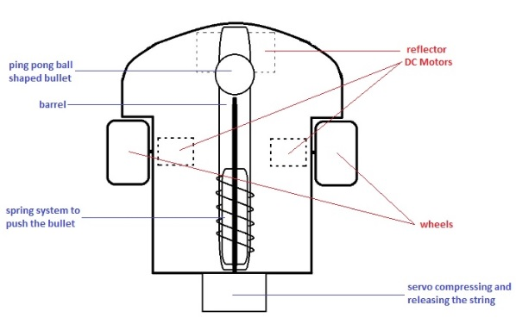

Figure 11-Top-View of Firing subsystem

* + 1. **POWER SUBSYSTEM**

Power sub-system is an prior system which is directly related with other sub-systems. In order to make the all sub-systems work, thus making the whole system work as desired, correct power should be supplied from power sub-system to related components.

Our sub-system includes a battery, an appropriate voltage regulator whose output will supply the MCU that controls the whole system, and the motor driver who supplies the motors.

General block diagram for the power sub-system showing the relations between components and other sub-systems is shown in Figure 12*.*

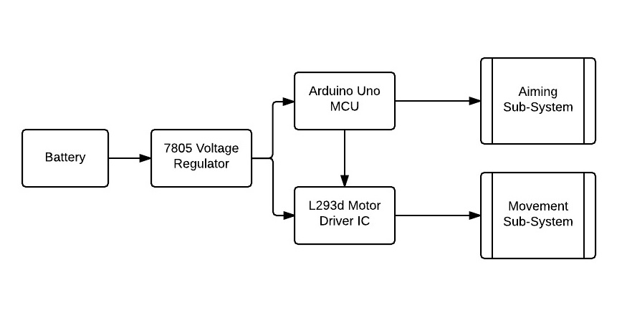

Figure 12-Block Diagram of Power Subsystem

As can be seen above, voltage regulator is connected to the output of the battery in order to regulate the incoming voltage to 5V. Later on, output of the regulator is connected to the MCU in order to supply the working voltage to it, therefore the MCU is able to control both movement sub-system and aiming sub-system. Also, output of the regulator is connected to the motor driver which also helps to the control of the movement sub-system.

***Battery Selection:***

* **Zinc Carbon**

Zinc-carbon, also known as carbon-zinc or the Leclanché batteries are one of the earliest and least expensive primary batteries. They are preferable due to their low costs.

* **Alkaline**

Alkaline bateries delivers more energy at higher load currents than zinc-carbon. Furthermore, a standard alkaline provides about 40 percent more energy than the average Li-ion while it is not as strong as Li-ion under loading. Alkaline has very low leakage not leak electrolyte when depleted as the old zinc-carbon does, but it is not totally leak-proof.

* **Lithium Iron Disulfide**

Lithium Iron Disulfide (Li-FeS2) is a new generation of the primary battery family and supplies improved performance compared to alkaline. It has a higher capacity and a lower internal resistance than alkaline. Moreover, by the help of very low leakage current, under rated temperature they have very long life.

* The battery selection is critical for having sufficent performance and long-life operation. Since the vehicle contains significant amount of motors, a detection mechanism that may consume high power and vehicle needs high power ratings in total, Alkaline batteries seem to be more convenient.

***Voltage Regulator (LM7805) Selection:***

A voltage regulator generates a fixed output voltage of a preset magnitude that remains constant regardless of changes to its input voltage or load conditions. Since there will be a voltage drop on our Zinc Carbon battery during operation and we have not constant power dissipated on the robot, we need to use a voltage regulator. Using LM7805 looks like best solution for us due to its popularity in such applications.

* + 1. **TEST RESULTS**

***Sonar Test***: Sonar tests are done to sense the presence of an object at a specified distance. Angle of sight, maximum distance of measuring and also speed of the operation have been investigated.

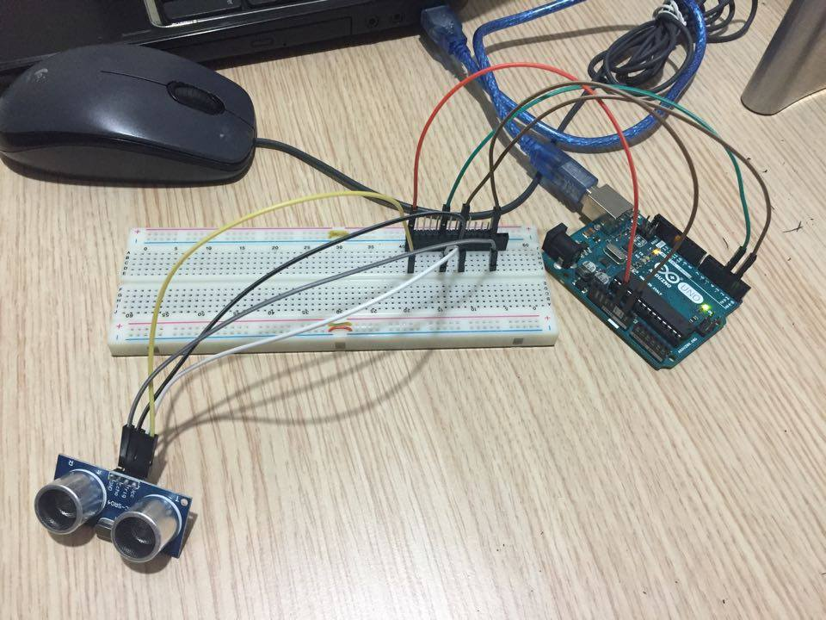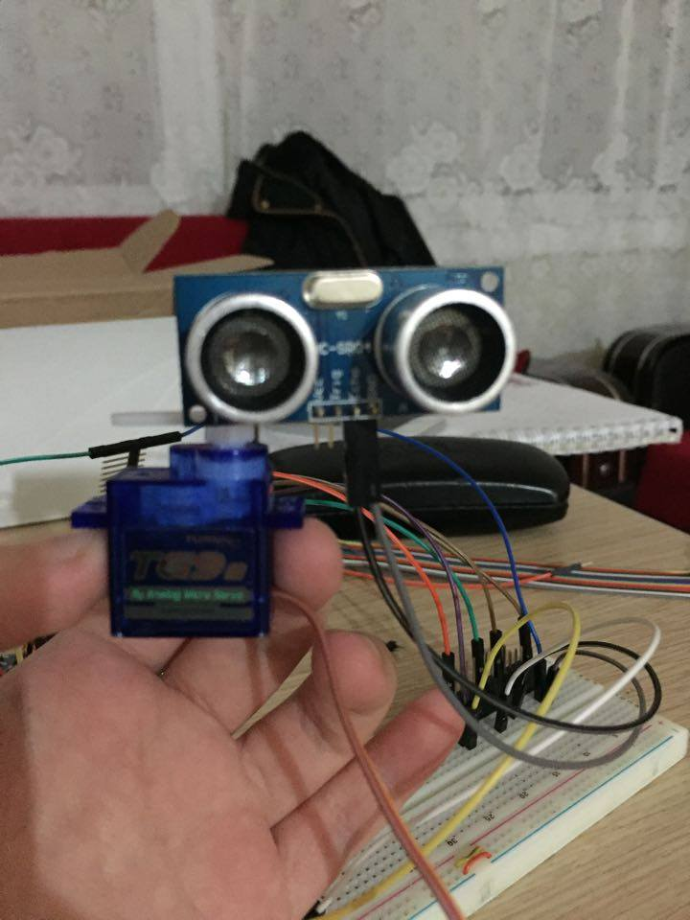

Figure 13- Sonar Sensor, Alone& Mounted on Servo

|  |  |  |
| --- | --- | --- |
|  | **Expectance** | **Result** |
| **Distance Range** | 2cm-400cm | 2cm-250cm |
| **Measuring Angle** | 150 | 20o |
| **Speed** | High Speed Measurement | Data per 50msec |
| **Surface Area** | 0.5m2 at maximum distance 400cm | Higher than A4 surface area at a distance larger than 1 meter |

Table 15-Comparison of Result

* Reasonable measurements up to 2.5 meters, which is larger than the maximum distance of the platform.
* The scanning angle of the sensor is 20 degrees, which is not an accurate way to lock onto the target.
* Sufficient speed of operation compared to the speed of the movement of the whole vehicle.

***IR Tests:*** Tests of IR sensor has been done. Maximum distance of measuring, angle of sight and operation speed have been investigated.

|  |  |  |
| --- | --- | --- |
|  | **Expectance** | **Result** |
| **Distance Range** | 5-100 cm | 10-80cm |
| **Measuring Angle** | 40 | <4o |
| **Speed** | High Speed Measurement | Data per 20msec |
| **Surface Area** | >75cm2 at 50cm | >75 cm2 at 70cm |

Table 16

* Range of measurement turned out to be less than expected. Expected results were convenient for the solution. However, test results stated that IR sensor is not a proper way to detect the presence of the object at a distance longer than 70cm because distance upto the opponent may be higher than even 1 meter during the game.
* There was no problem regarding the minimum surface area that can be measured at a specified distance. Since the opponent robot is assumed to have an area larger than approximately half size of the A4 paper (300cm2), IR sensor is convenient in terms of the surface area range.

***Image Processing Tests:*** Color detection algorithm is implemented in MATLAB to track the specified color with a marker on the video screen. Approximate index number of the center of the target has also been extracted. In the Figure 15, two images have a yellow marker that points out the location of the red object while Figure 16 images have blue marker that points out the location of the red object.

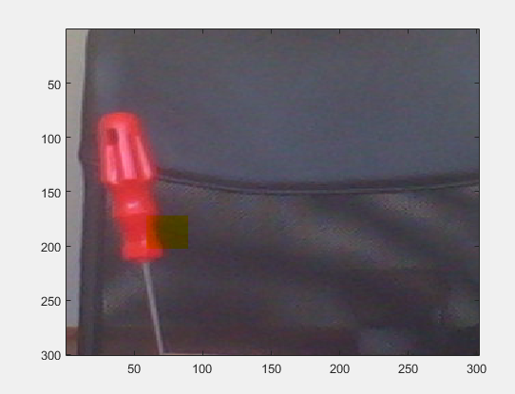

Figure 14

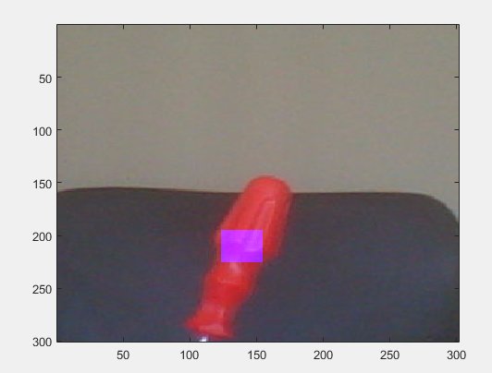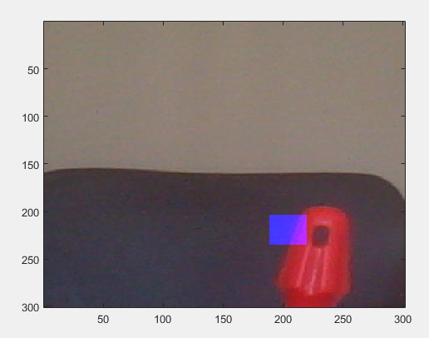

Figure 15

|  |  |  |
| --- | --- | --- |
|  | **Expectance** | **Result** |
| **Distance Range** | >1.5m | Up to 2meters |
| **Speed** | Medium Speed Measurement (depends on resolution) | >20 FPS(Frame Per Second) @300x300 Resolution |
| **Width of Frame (related to angle of sight)** | >1 meter due to the game field’s dimensions | >1 meter @ 300x300 Resolution & @1 meter distance |

Table 17

* Test results show that range of the method is sufficient to detect the opponent in the game field which has 2x1m dimensions
* Operation speed highly depends on the resolution of the streamed image. However, at a reasonable resolution, operation speed is high enough compared to the movement speed of the robot.
* Similar to range characteristics, width of detection is sufficient for camera placed outside the game field.
* For the tests, red colored object is tracked. Although very accurate and precise detection of target could not be achieved due to the noise interference in the environment, results were relatively successfull in terms of the understanding of basic colored object tracking principle.
* Light intensity in the environment may cause serious distortion on the algorithm. Besides, unrelevant object with the same color may cause disturbance in detecting the original object. Therefore, additional complex algorithms will be needed in order to debug the system and improve the performance.
* For only the test results, red color has been tracked. However, at the end, it will be changed as green.

**Movement Tests:** Utilization of Reflectance Object Sensor has been tested. The aim is to keep the vehicle within the borders of our side of the game field. Black surface yields forward motoring while white surface(borders) yields manuevering and turning back to the inside of the field. Tests have been successful.

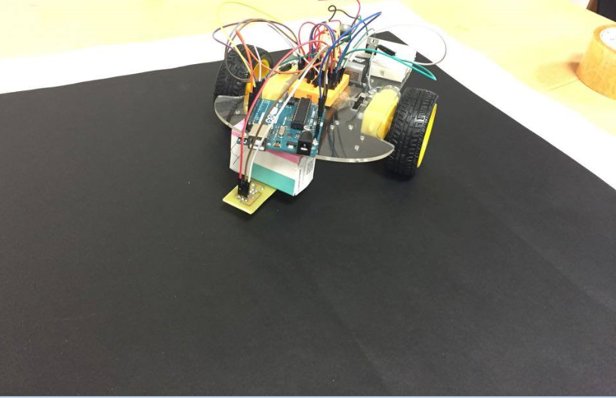

Figure 16

|  |  |  |
| --- | --- | --- |
|  | **Expectance** | **Result** |
| **Speed** | Maneuvering in <1 second | <1 second manuevering time |
| **Sensing Capability of Width of the White Borders** | <2cm width white lines due to Standard Compliance (4.1) | Approximately 2cm width borders have been detected |
| **Measuring Distance** | 0.5-2cm | 1cm is optimum |

* Original game field has been simulated with determined colors which are black and white.
* Vehicle contains a reflectance sensor in front of the body which is 1cm above the ground. As soon as the white color is detected, vehicle immediately turn 180o and continue its regular operation in the game field.
* Sensor cannot distunguish the difference of white and black surface in less than 0.5cm. 1cm is observed as the optimum distance.
  1. **PLANS & PROJECT MANAGEMENT**
     1. **TASK DIVISION AND RESPONSIBILITIES**

The main system of the robot consists of certain subsystems. These subsystems are formed to accelerate the whole process, decrease the complexity and increase the efficiency. Each subsystem is explained in detail in the solution part already. Each company member is responsible for certain subsystems.

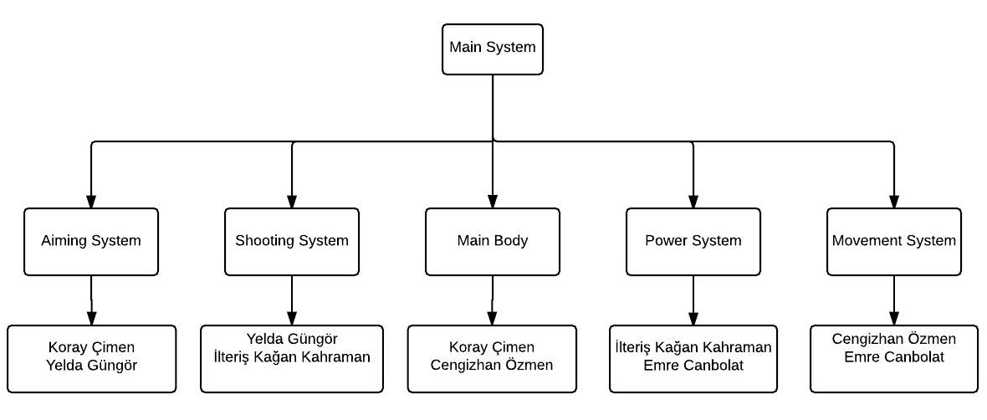

Figure 17-Task Divisions

At the beginning of the project, each team member was responsible for literature reasearch to produce alternative solutions to requirements. According to the literature research results, each member specified his/her area of interest and each team member is assigned to related subsystems. Progresses on each subsystems and evaluations have been discussed so that each member has sufficient awareness of the whole situation.

* + 1. **GANTT CHART**
    2. **COMPLETED TASKS**
* Infrared and ultrasonic sensors are purchased. A few tests based on their working principles have been done. Possible defficiencies have also been investigated.
* Communication between the computer, MCU and sensors have been achieved. When an object is detected, related data can also be processed in laptop.
* Motor driver utilization has been accomplished. Both motors that are responsible for the movement have been driven in a desired manner.
* Chasis Movement

A prototype of chasis has been purchased. Chasis consists of two DC motors to move and a caster wheel for stability on a flat surface. Vehicle has the driving ability to any direction in the field.

* Detection

A servo motor has been installed. Communication between MATLAB, MCU and actuator(servo motor) has been accomplished. According to the location of specified colored object, servo motor is able to orient itself to the required direction.

* Micro-Controller

Arduino Uno has been purchased. Successfull operation between detection and movement subsystem components and MCU has been achieved.

* + 1. **PLANNED TASKS**
* Image processing will be done to detect the target and it will be the main detection strategy.
* Final decision on bullet size will be determined. Mechanical design of firing system will also be finalized with better performance.
* Motor driver will be replaced with a better one in order to increase the speed and power of the movement.
* Mechanical structure of firing subsystem will be mounted on a proper motor, possibly a servo or a DC motor with proper gears.
* Additional sensors will be used to increase the performance of the subsystems(possibly target detection system).
* RF communication will be installed with a radio or bluetooth. Communication between computer and MCU will be achieved wirelessly.
* Reload system will be designed outside the game field.
* Magnetometer will be utilized in order to get body frame data of the robot to be used in orientation of the body. It shall be used to point at the rival’s field constantly
* Successfull communication and method will be developed for turn taking.
  + 1. **POSSIBLE RISKS AND CHALLENGES**

There may be some possible challenges that we may come up with during the progress.

* Sensors as well as camera do not always give desired outputs. Besides, noise interference of the environment may cause undesired outcomes.
* Video processing may be achieved by lower resolution to increase the operation speed which yields low accuracy. Small and fast objects may not be detected accurately.
* Interference of components that are same with the opponent’s robot may disturb the related subsystem which in turn causes both robots to act in undesirable manner.
  + 1. **DELIIVERABLES**

## Equipment

* Main Device (Robot)

A robot which is capable of dueling the opponent having necessary intelligence will be provided.

* Extra ammunition

Extra ammunition for reload will be provided.

* Platform

A 1x1m field for the device to operate will be provided.

* Battery

A battery capable of longtime operation will be provided to the user. It is going to be chargeable.

* Wireless on/off switch

A wireless device, which starts or stops the robot will be provided.

## Documents

* Warranty

Korilent will provide 2 years warranty of the whole components, in case of breakdown of the materials before 1000 duels.

* User Manual

A how to use manual will be provided.

* + 1. **COST ANALYSIS**

|  |  |
| --- | --- |
| **Product** | **Price (USD)** |
| Ardunio Uno (x1) | 10 |
| Motor Drive(x1) | 1 |
| Motor Chasis(2 DC motors, 2 standard wheels and1 caster wheel included)(x1) | 18 |
| Servo Motor (x2) | 10 |
| Ultrasonic Sensor (x1) | 2 |
| Infrared Sensor (x1) | 15 |
| DC Motors (x2) | 8 |
| Magnetometer(x1) | 10 |
| Other(Mechanical Stuff) | 10 |
| Total | 84 |

Table 18

* 1. **CONCLUSION**

This conceptual design report is being published due to the informing the customers about the product of the Korilent is going to be published at the end of the 2016,May at its finalized version. The technical details and further classifications of the product were pointed out by informing the reader with the component analysis and test results. Possible approaches, both finalized and not finalized versions, of the solutions were given for broadening the knowledge of the customer through what the product will look like and work like at the end of the project duration. Several alternatives are supplied to let the customer feel free to demand further developments and customizations on the product. Since during our design and implementation time, the members were still trying to improve current solution and finding a better process instead of sticking into the one solution, according to company policy, customers also have rights to change their demands. While the implementation of the different sub-systems, company comes up with new constraints, thus every solution mentioned in this report may not be permanent. After this project has finished, with the knowledge and experience got from the process, the company will be capable of taking more complicated and higher budgeted projects both in robotics and image processing areas.

The preferred design is a duelling robot, having the specifications of sensing the turn and deciding whether to shoot or to dodge the bullet, sensing the position of the opponent (on both turns) and decision-making of changing its position (artificial intelligence). This is rather an interesting area of designing a robot, as well as being hardship to design.

Previously, the company’s members profiles, the works done ever since with some technical information, organizational structure, goals of the projects, solution of the project with various approaches and the current statement of the product is explained. In addition to body diagram of the work plan and a ‘Gantt Chart’, cost analysis and material selections and complete studies were indicated.

To conclude, Korilent supplied all the information about the product throughout the report that are evidence of the company satisfies all the demands of the customer. Furthermore, by the ending of that project, all the products that developed by the company are going to be dominating the robotics market.

1. **APPENDICES**

**APPENDIX A**

**REFLECTANCE OBJECT SENSOR**

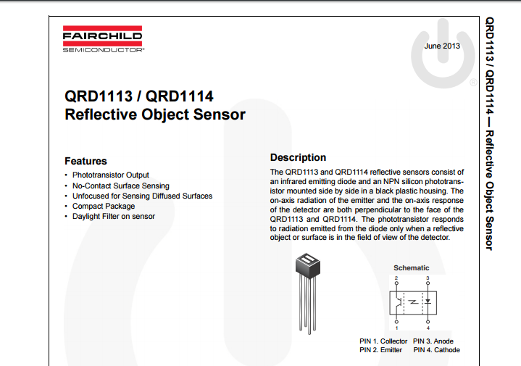

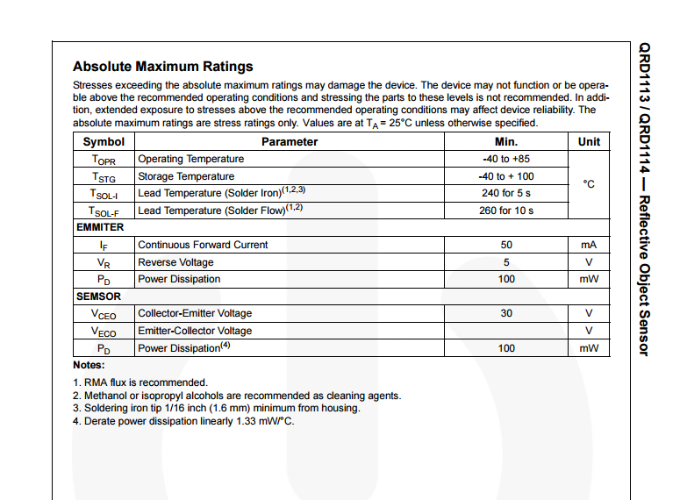

**APPENDIX B**

**ULTRASONIC SENSOR**

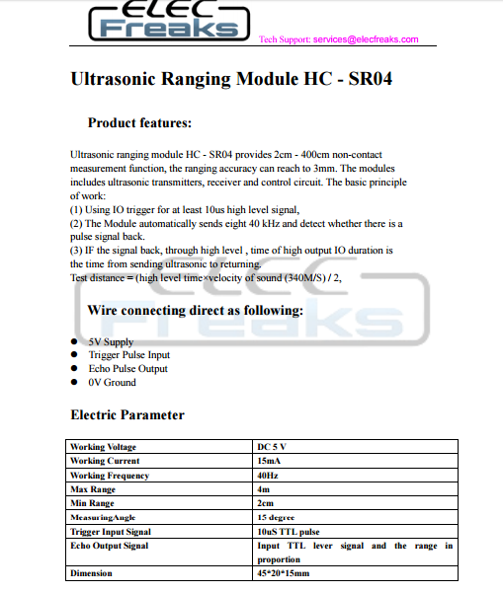

**APPENDIX C**

**SERVO MOTOR**

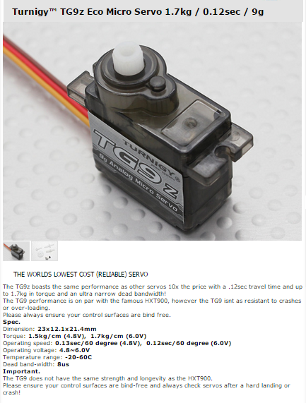

**APPENDIX D**

**IR DISTANCE SENSOR**

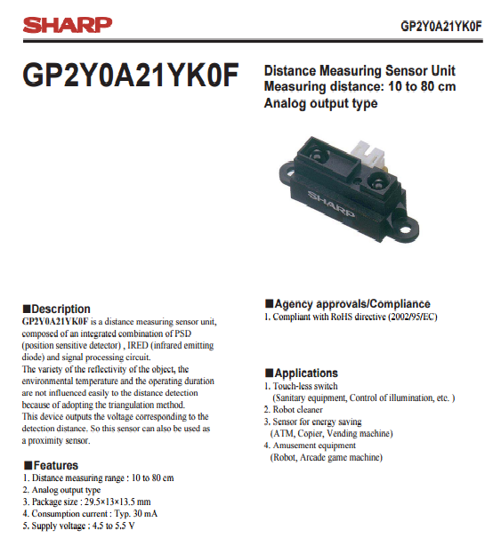

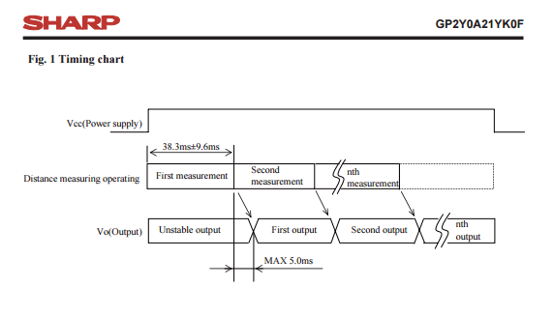

**APPENDIX E**

**MOTOR DRIVER**

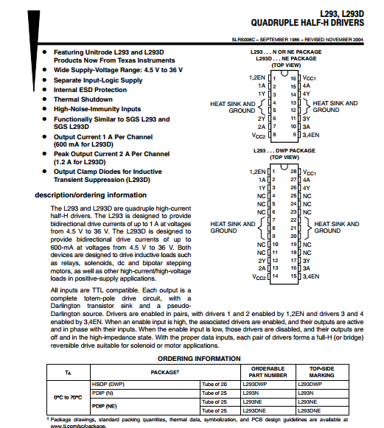

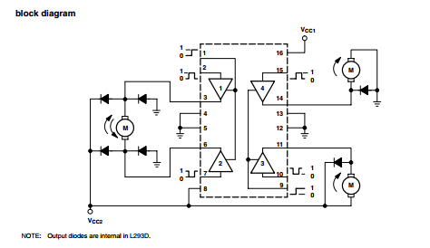

**APPENDIX F**

**STANDARD DIRECTIVES**

